Client Name:
Roland
Client Address:
1010 Suncrest Street, Bryan, 77803
Phone Number:
979-599-0073

Distance from the Church:
2.4 miles - 8 minutes

Description of the work:
Demo existing porch
Rebuild porch

Other Notes:
There is a metal roof that will determine the exact size of the deck
Look into adding gutter that is on site to roof
Little shade
Might be 4 blocks on site to reuse

Site Pictures
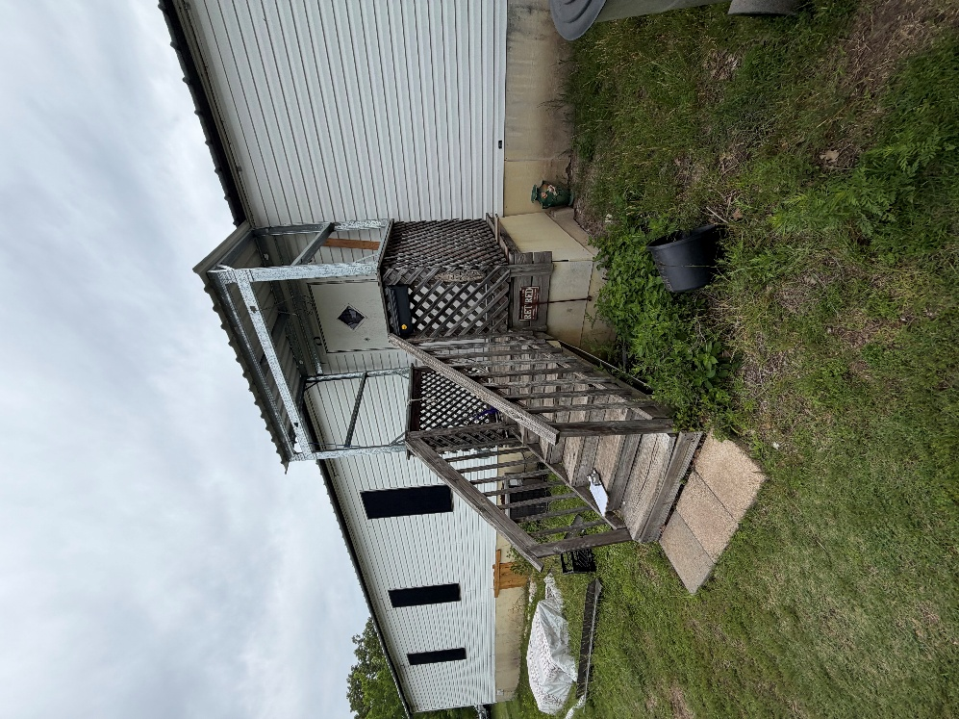
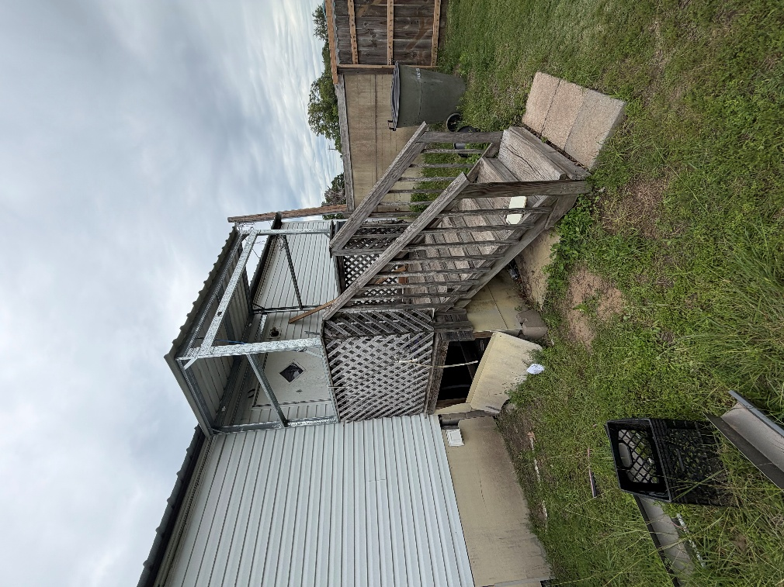
Rendered Project
“Build to site not to plan”

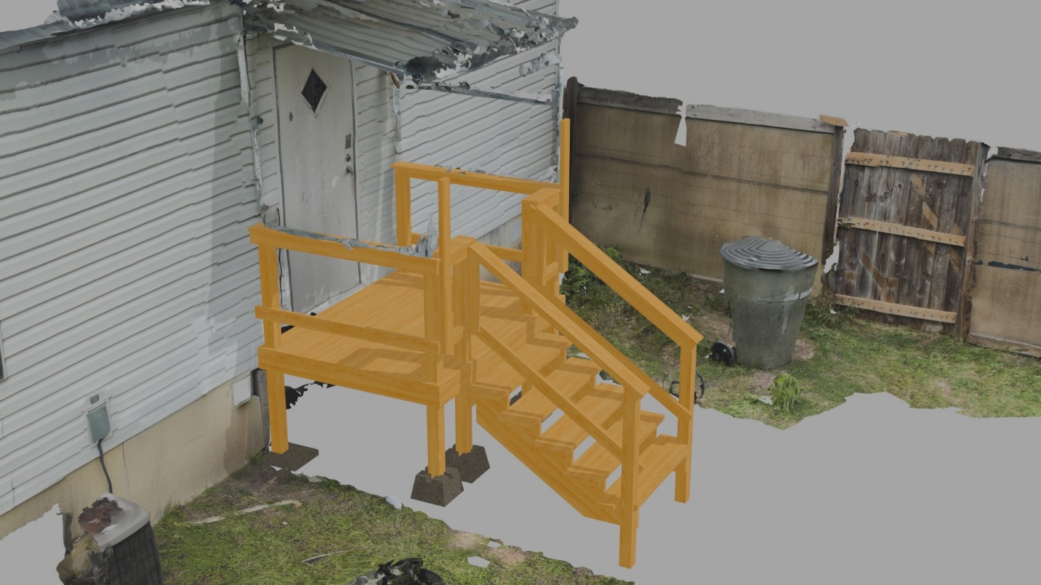
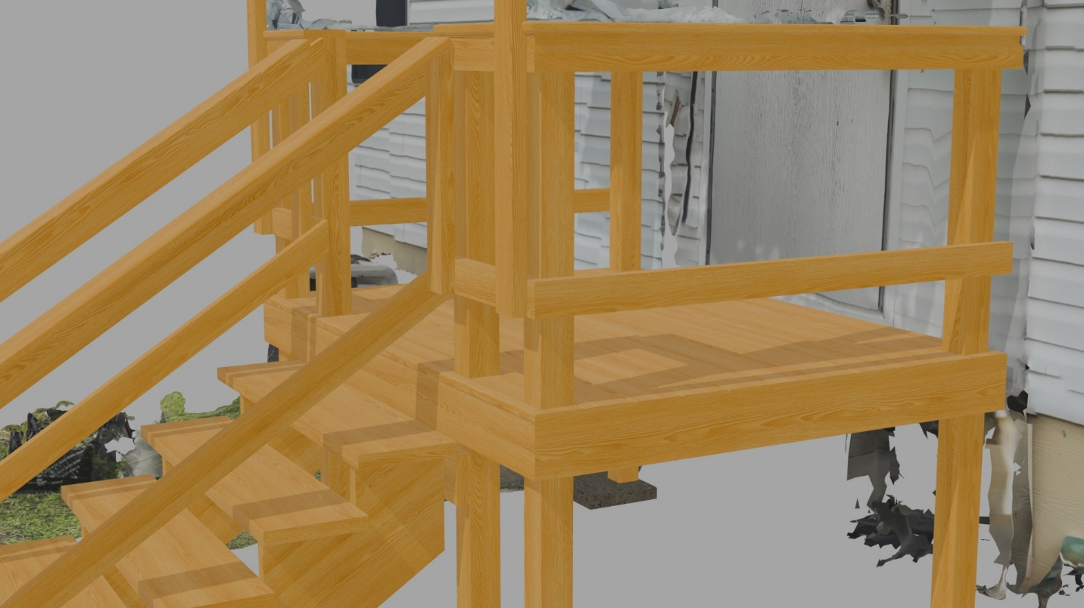
Building Notes
- Frame
  - Width and length should match the roof
  - Add extra 4ft 2x4 to better support the roof in the front
- Handrails and posts
  - Check with clients with how they would like the stairs, design shown is in the middle
    - If client wants the stairs to either side of the deck you can save a post
- Decking
  - Might want to start with the complex first cut with the 4 posts
    - Support any part of the deck with cleats if needed
- Stairs
  - Do NOT trust the design
  - Remeasure and recalculate on site

